Rotary Club of Kathmandu Mid-Town
Breakfast Chatter



4 August 2006 The Weekly Bulletin of Rotary Club of Kathmandu Mid-Town Bc # 5 of 2006-07

District : 3290 Web: www.rotarymidtown.org.np Club Id : 26776

AUGUST IS MEMBERSHIP DEVELOPMENT AND EXTENTION MONTH
Membership development is one of the elements of an effective club. A well-crafted and positioned membership development strategy is essential for the club to operate successfully and fulfill
the Object of Rotary.
A comprehensive membership development plan must incorporate well-developed strategies for:
Retention,
Recruitment,
Organizing new clubs.

Talk Program on Educating Disadvantaged Children of Nepal
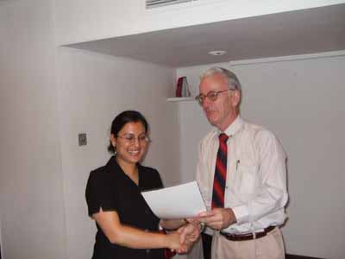
Guest Speaker Inku Subedi being given a Letter of Appreciation for her presentation at Club meeting
on Friday 28 July morning by President-Elect Walter Diller.

Weekly Meetings and Programs
Date | Program/Speaker | Program/Topics of Presentation
4 August 2006 | Club Assembly | Plan and programs for the year 2006-07
11 August 2006 | Dr Som P Pudasaini | UN roles in peace process
18 August 2006 | Dr Sumitra Manandhar | Presentation on Karnali Anchal
25 August 2006 | Bhimarjun Acharya | Making Constitution through Constituent Assembly

Friday, 4 August, morning :
Club Assembly, the first club assembly of the year 2006-07 will have presentations on Club plan and programs for the year.
Mid-Towners know Club Assembly is prime mover of Rotary weeklies !

Youth Exchange Student returns :
Anita Giri, RYE student of Kathmandu Mid-Town has returned home on Friday, 28 July 2006 after completing her year in Germany. Besides her father and brother, Kathmandu Mid-Towners: Werner Blaser, Lotti Weise, Komal Chitracar, Saroj Shrestha and RR Shrestha were there at Tribhuban International Airport to receive her. She had left Kathmandu on 16 August last year for spending a year in Germany as RYE student.
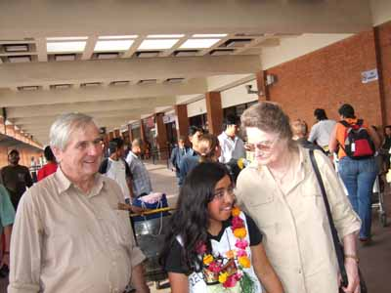
Rtn Werner Blaser and Rtn Lotti Weise receiving Anita Giri at TIA, Kathmandu

Gastronomic Fellowship :
This year's first Gastronomic Fellowship (second in the series, the first one was celebrated on 14 May 2006) was held on Saturday, 29 July at
Venue: Trattoria Nuovo Marco Polo, Amrit Marg near Bhagawan Bahal
This time it was featuring Italian cuisine.
Italy was on the news : World Cup and fightings too !
Altogether 24 gastronomers including spouses and children enjoyed the delicasies, like pollo alla diavola, ravioli or maiale tonnato, while for the vegetarians Spaghetti al Pesto was served and kids enjoyed their Pizza's and drinks.
Only two w's were served – wine and water ! Whisky lovers were starving !!

Beware !
Alcohol kills slowly !
So what ? Who's in a hurry ? Are you ?

Mid-Towners !
If you have any informtion on Rotary activity that you think should be interesting to other fellow Rotarians please send it for inclusion into the BC to make it more informative and interesting as well.
Thanks

As a Rotary leader, I ask you to Lead the Way by strengthening your clubs, so that they become even more attractive to potential new members and keep the members they have for years to come. Stronger clubs make it far more likely that your clubs will attract the kinds of members you want as your fellow Rotarians.
RI President William B. Boyd

4 August 2006 The Weekly Bulletin of Rotary Club of Kathmandu Mid-Town Bc # 5 of 2006-07

Editor: RR Shrestha, Club Service Director email: rryes@wlink.com.np

